Chapter 18, Solution 30.

(a) 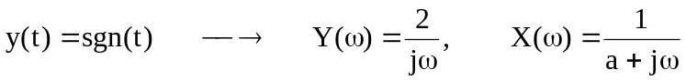

(b) 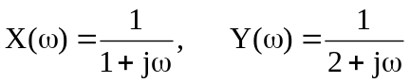

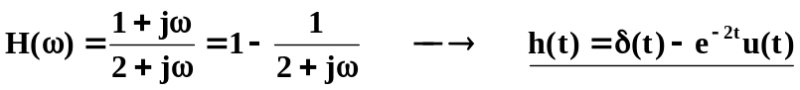

(c ) In this case, by definition, 